-
Bridgepoint Parts Catalog

Section XXIII: Direct Drive Components Page 1

PHY016-034

Clutch Housing Assembly

with Poly Groove Clutch

Standard Housing

Assembly Components:
Clutch: PHY036-003
Shaft: PHY150-009
Bearings: PHY008-011 (QTY 2)
Snap Ring: PHY139-005 (QTY 2)
Front Key: PHY077-008
Rear Key: PHY077-009
Housing: PHY092-005

PHY016-120

Clutch Housing Assembly

with Poly Groove Clutch

1997-2002 Chevy w/AC Housing

Assembly Components:
Clutch: PHY036-003
Shaft: PHY150-009
Bearings: PHY008-011 (QTY 2)
Snap Ring: PHY139-005 (QTY 2)
Front Key: PHY077-008
Rear Key: PHY077-009
Housing: PHY015-154
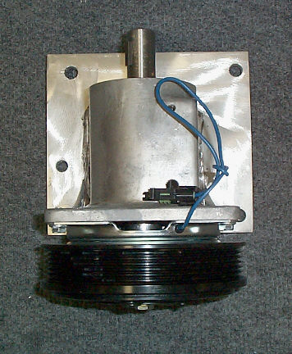
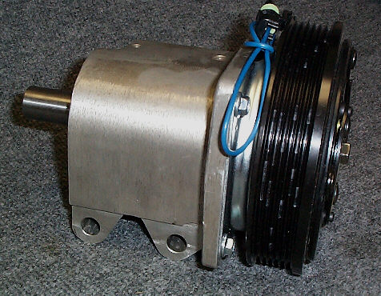

PHY016-122

Clutch Housing Assembly

with Poly Groove Clutch

99+ Ford & 2003 Chevy Housing

Assembly Components:
Clutch: PHY036-003
Shaft: PHY150-009
Bearings: PHY008-011 (QTY 2)
Snap Ring: PHY139-005 (QTY 2)
Front Key: PHY077-008
Rear Key: PHY077-009
Housing: PHY015-149

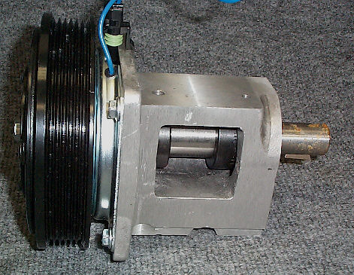

PHY036-003

Clutch 6” Poly Groove 12VDC

Hydramaster CDS
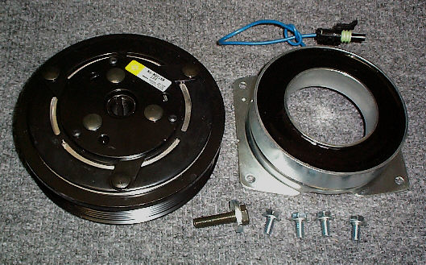

DBSE stands for Distance Between Shaft Ends. It refers to the measurement from the end of the clutch shaft to the end of the blower shaft.

If your measurement does not fall in any of the following listed ranges, you may have to move the power pack or a special shaft can be made to fit your measurement.

PHY109-091

Pulley Assembly – CDS Idler

Pulley with bearing

Hydramaster: CDS units in 1997-2003 Chevy & GMC
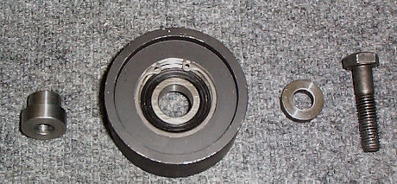

PHY150-060

Drive Shaft CDS Series 1

Compressed Length 28”

Order this shaft if your DBSE measurement is
between 27.75” & 33”.

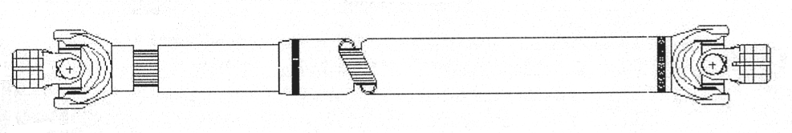

PHY169-070

Solenoid Valve – Vacuum

12VDC – Hydramaster

Vent Plug: PHY106-014
Barb 1/8” x 1/8”MPT: BR002

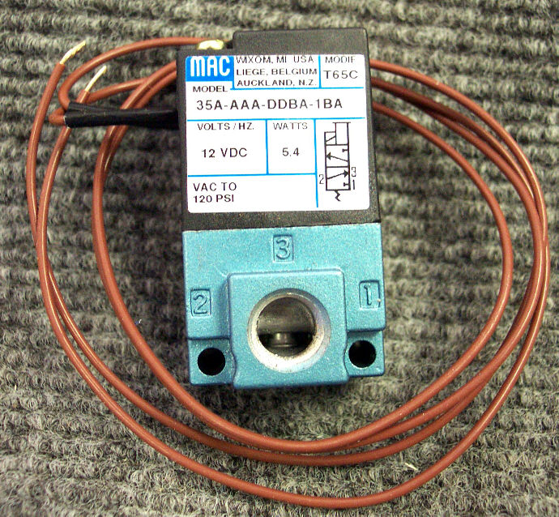

PHY150-061

Drive Shaft CDS Series 2

Compressed Length 33.50”
Order this shaft if your DBSE measurement is
between 33.25” & 38.50”.

PHY183-001

Vac Throttle Booster Pod

Hydramaster CDS
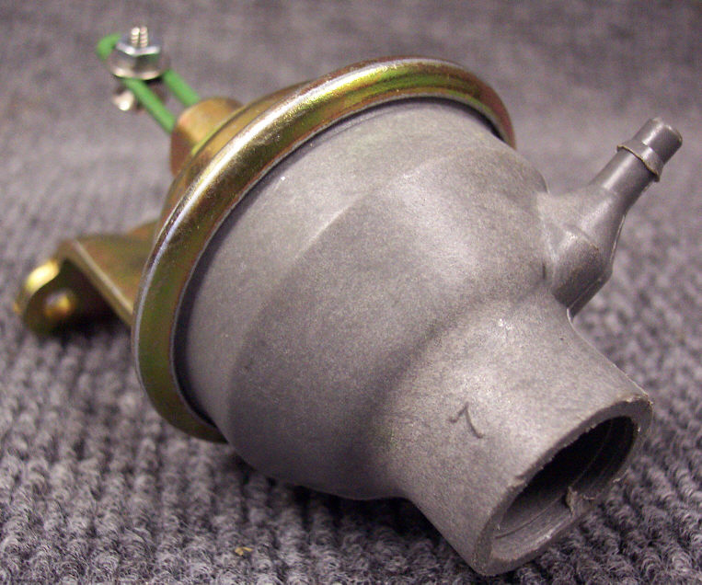

PHY150-062

Drive Shaft CDS Series 3

Compressed Length 39”

Order this shaft if your DBSE measurement is
between 38.75” & 44”.

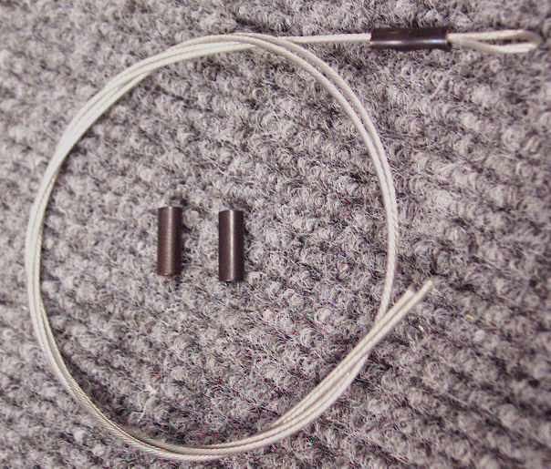

PHY025-009

Cable Assembly CDS Throttle Booster Pods

Bridgepoint Parts Catalog

Section XXIII: Direct Drive Components Page 2

PWM-A033S-1

Clutch 6” Poly Groove 12VDC

White Magic: All Direct Drives
except 98+ Dodge

PWM-F003

Drive Shaft Assembly 71-1/2”

97+ Ford
White Magic: All Direct Drives
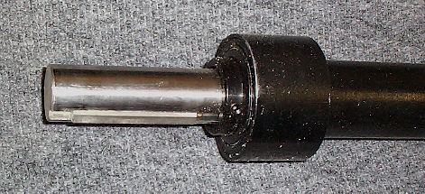
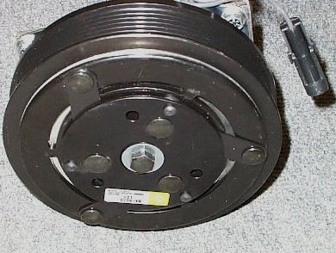

PWM-F0045

Drive Shaft Assembly 77-1/2”

97+ Chevy / GMC
White Magic: All Direct Drives

PWM-A033

Clutch Dual Groove 12VDC

White Magic: 98+ Dodge Direct Drives

PWM-F008

Drive Shaft Assembly 67-1/2”

98+ Dodge
White Magic: All Direct Drives

PWM-G056S

Belt Serpentine 6 groove 56”

97+ Chevy / GMC

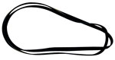

PWM- A140

Solenoid Valve – Vacuum

12VDC – White Magic

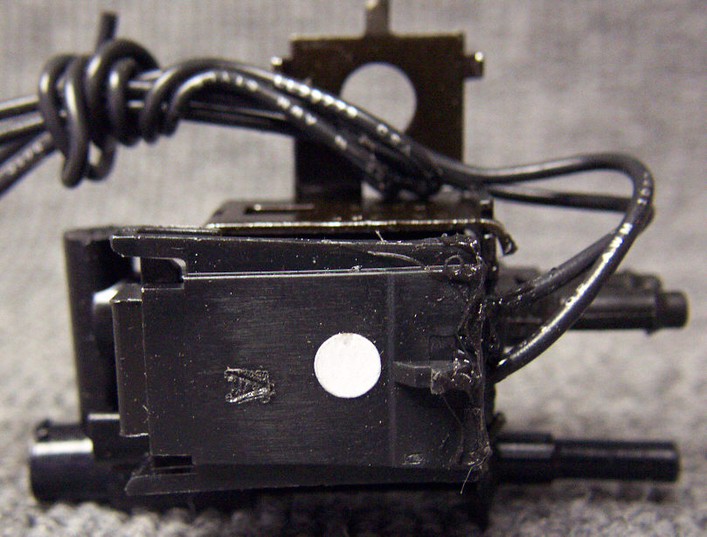

PWM-G062S

Belt Serpentine 62”

97+ Ford

PHY010-003

Belt Serpentine 120.3”

Hydramaster CDS
97+ Chevy with AC new style CDS kit with extra idler pulley

PWM-VA64-1

Vacuum Actuator Unit

White Magic
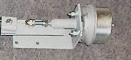

PWM-A041-8

Cable Assembly – Throttle Control

White Magic - Chevy, GMC & Dodge

PHY010-047

Belt Serpentine 107.5”

Hydramaster CDS
97+ Chevy with AC old style CDS kit without extra idler pulley
92+ Dodge with AC
(Substitute for 010-039 108” belt)
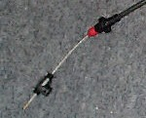

PWM-A041-2

Cable – Throttle Pull

White Magic - Ford
Sold per foot

PHY010-040

Belt Serpentine 110”

Hydramaster CDS
97+ Chevy without AC

PHY010-118

Belt Serpentine 114.5”

Hydramaster CDS
2003+ Chevy with AC new style CDS kit with extra idler pulley
(Air conditioning compressor has its own factory belt which is not changed during CDS installation.)

PHY010-041

Belt Serpentine 96.5”

Hydramaster CDS

92+ Dodge without AC

PHY039-015

U-Joint CDS Drive Shaft
New Style - For PHY150-050, PHY150-057, PHY150-058 & PHY150-059 Spicer Shafts

PHY010-053

Belt Serpentine 63.7”

Hydramaster CDS

99+ Ford

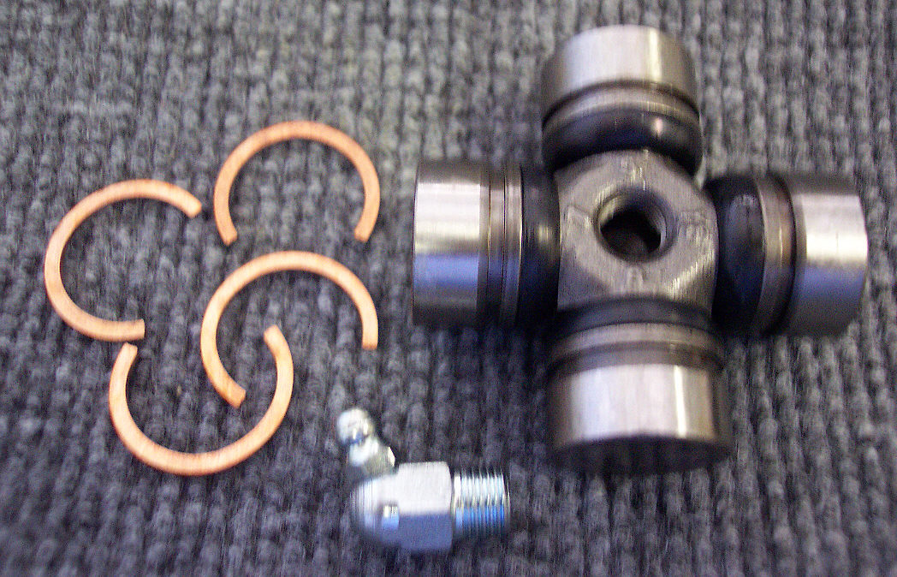

Bridgepoint Parts Catalog

Section XXIII: Direct Drive Components Page 3

PP40-902149

Motor – Hydraulic Drive

Prochem: PTO

PP41-905053

Pump – Hydraulic Drive

with 12VDC Clutch

Prochem: PTO

PP44-802301

Coupler Insert

Hydraulic Motor / Blower

Prochem: PTO
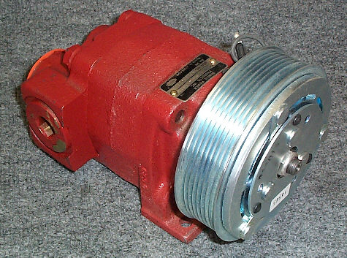

PP14-806564

Filter Hydraulic Oil

Prochem: PTO
Gasket: PP43-807567

PHY150-040

Shaft CDS 4.8/4.6 Power Pack

Jack Shaft

PP14-806565

Strainer Hydraulic Oil

Prochem: PTO

PHY008-020

Bearing Pillow Block

CDS 4.8/4.6 Power Pack

PHY074-165

Electronic Throttle Control

Hydramaster CDS

GM - 2006 to mid 2007

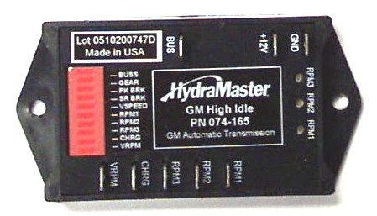
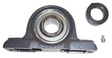

PHY074-

Electronic Throttle Control

Hydramaster CDS

GM - mid 2007+

PHY010-051

Belt Pump CDS 4.8

V-Belt #9380

PHY010-012

Belt Pump CDS 4.6

V-Belt #9325

PHY074-

Electronic Throttle Control

Hydramaster CDS

Ford - mid 2006+

